AI-Powered HR Analytics Dashboard
Project Report

1. Introduction
Modern organizations generate vast volumes of Human Resources (HR) data covering workforce demographics, compensation, performance, and engagement metrics. Despite this abundance of data, extracting actionable insights remains a challenge due to reliance on manual reporting, technical query writing, and analyst dependency.
The AI-Powered HR Analytics Dashboard addresses this gap by enabling natural language interaction with HR data, allowing decision-makers to obtain business-ready insights instantly. The system integrates Artificial Intelligence, SQL analytics, and an interactive web interface to convert plain-English questions into accurate, real-time HR analytics.

2. Problem Statement
HR and leadership teams face the following challenges:
- Heavy dependence on manual SQL queries and analysts
- Long turnaround time for answering simple business questions
- Insights that are technical and not executive-friendly
- Limited self-service analytics for non-technical users
- Difficulty in correlating workforce metrics across departments and roles
These limitations slow down decision-making and increase operational risk.

3. Project Objectives
The primary objectives of this project are:
- Enable users to ask HR questions in simple English
- Automatically convert questions into validated SQL queries
- Fetch insights from live SQL Server HR data
- Present results through a professional, interactive dashboard
- Generate AI-driven executive explanations instead of raw tables
- Ensure scalability, accuracy, and filter-aware analytics

4. System Overview
The solution is implemented as a web-based HR analytics platform using:
- Streamlit for UI and dashboard rendering
- SQL Server as the HR data source
- Groq LLM (LLaMA 3.1) for natural language understanding
- Python (Pandas, PyODBC) for data handling and execution
The system supports both analytical queries and employee-level drill-downs.

5. Dataset Description
The HR dataset is stored in a SQL Server database and includes:
- Demographics: Age, Gender, Marital Status
- Organizational Data: Department, Job Role, Education Field
- Compensation: Monthly Income, Daily Rate, Hourly Rate
- Experience: Total Working Years, Years at Company
- Engagement & Satisfaction: Job Satisfaction, Work-Life Balance
- Performance: Performance Rating, Promotion History
The dataset is treated as a live enterprise HR database, not a static file.

6. System Architecture and Workflow
6.1 End-to-End Workflow
- User Input
The user enters a business question in natural language (e.g.,
“Which job roles have below-average salary but high employee count?”)
- Semantic Normalization
Business terms (salary, experience, promotion) are mapped to valid database columns.
- Intent Extraction via AI
The LLM returns a strict JSON structure defining:
  - Metrics (COUNT, AVG, etc.)
  - Group-by dimensions
  - Filters and conditions
- SQL Query Generation
The system constructs safe, validated SQL queries using column metadata.
- Query Execution
SQL is executed on SQL Server and results are returned as a DataFrame.
- Filter-Aware Analytics
Sidebar filters (Gender, Department, Job Role, Education) dynamically update:
  - KPIs
  - Tables
  - Insights
- AI-Generated Executive Insight
The system generates business-language explanations without recalculating metrics from sample data.

7. Key Functional Features
7.1 Natural Language to SQL
- Converts English questions into accurate SQL
- Eliminates manual query writing
- Prevents invalid column usage via schema validation
7.2 Dynamic KPI Engine
- Total Employees
- Average Age (rounded, no decimals)
- Gender Distribution
- Fully filter-aware KPIs
7.3 HR Filters
- Gender
- Department
- Job Role
- Education Field
Filters apply consistently across KPIs, tables, and insights.
7.4 Special Analytical Queries
- Detection of below-average salary & high headcount roles
- Benchmarking against organization-wide averages
7.5 Executive-Grade AI Explanations
- No misleading calculations from sample data
- Focus on trends, risks, and implications
- Designed for senior management consumption

8. Technical Design Highlights
- Session State Management to avoid re-execution issues
- Column Metadata Enforcement to prevent hallucinated SQL
- Safe Default Operators for missing query conditions
- Head-only Sampling with strict AI instructions to avoid incorrect summaries
- Separation of Concerns between query execution and explanation generation

9. Business Value and Impact
- Reduces HR query turnaround time from hours/days to seconds
- Enables self-service analytics for non-technical users
- Improves decision-making speed and accuracy
- Enhances workforce planning and compensation analysis
- Minimizes dependency on analysts and manual reporting
- Delivers executive-ready insights, not raw data

10. Key Learnings
- Demonstrated effective use of AI-driven analytics pipelines
- Showcased agent-style architecture for intent extraction and insight generation
- Proved feasibility of natural language interfaces for enterprise data
- Highlighted importance of guardrails in AI-generated SQL
- Reinforced the value of business-focused explanations over technical outputs

11. Conclusion
The AI-Powered HR Analytics Dashboard successfully bridges the gap between complex HR data and strategic decision-making. By combining AI, SQL analytics, and an intuitive dashboard, the system empowers organizations to transform raw HR data into meaningful, actionable insights—instantly and accurately.
This project demonstrates a scalable, real-world application of AI in enterprise analytics and serves as a strong foundation for future extensions such as attrition prediction, workforce forecasting, and advanced HR intelligence systems.

12. Future Enhancements
- Attrition risk prediction using ML models
- Trend analysis and forecasting
- Role-based access control (RBAC)
- Exportable executive reports (PDF/PowerPoint)
- Integration with ERP and HRMS platforms

13. Screenshot of UI
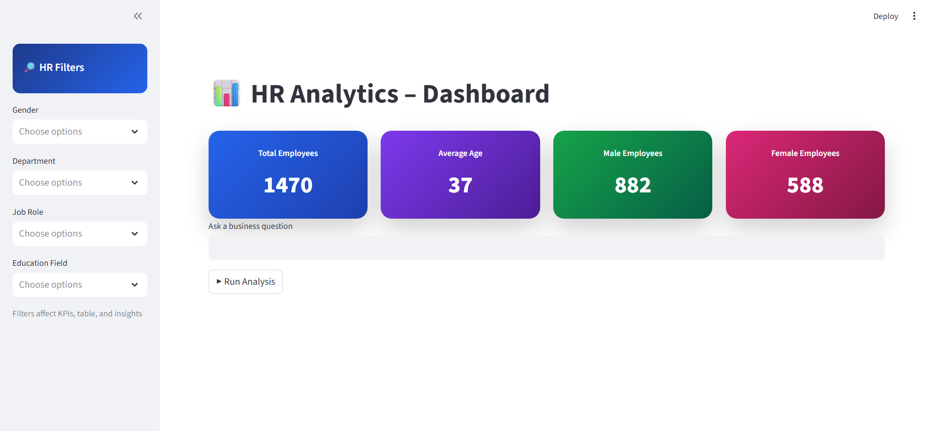

- Answers for query asked by user

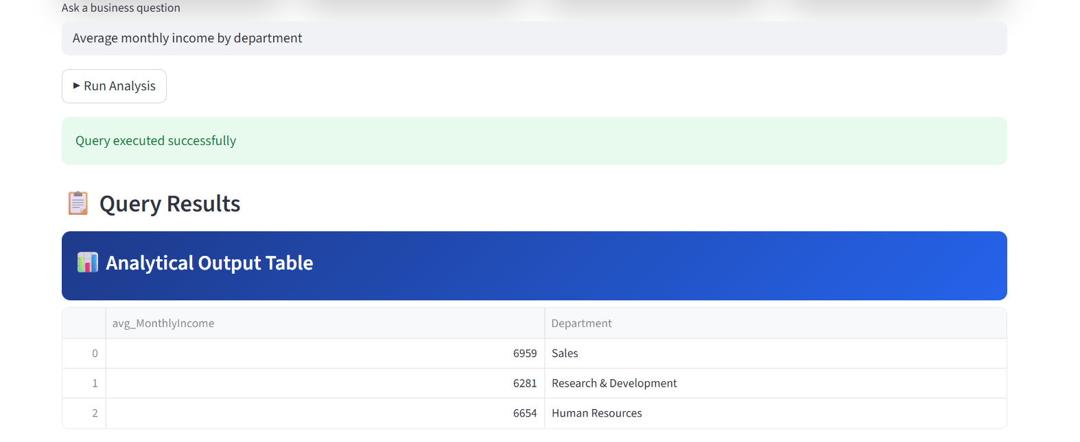

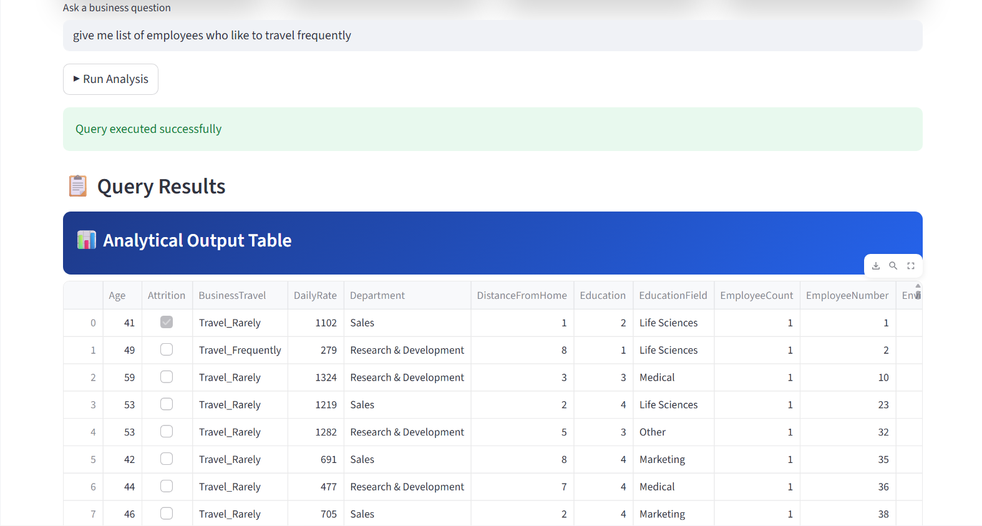

- AI GENERATED INSIGHT AND SQL QUERY FOR THE SAME
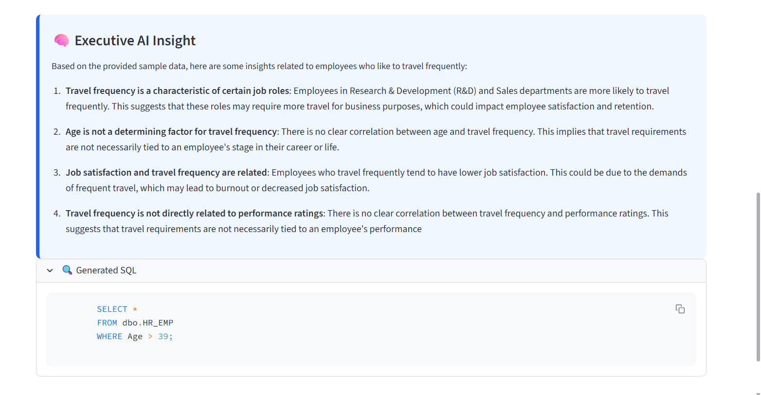
- DYNAMIC FILTER FOR DASHBOARD
